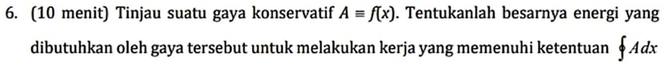

A = gaya.

Mencari besar energi:
$$W=Fs$$
$$∮\vec{A}⋅d\vec{x}$$
Jika ketentuannya titik awal=titik akhir. Karena untuk x(atau s) = 0, jadi W=0 juga.
Energi (W) = 0.
$$∮\vec{A}⋅d\vec{x}=0$$

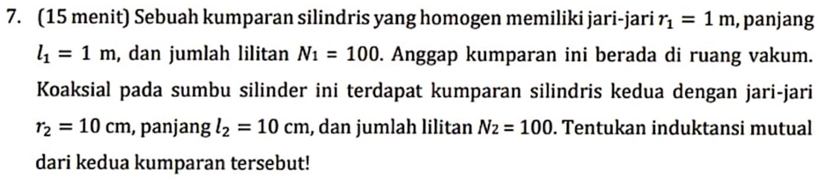
Diketahui:
R1=1m
L1=1m
N1=100
R2=0,1m
L2=0,1m
N2=100
Dicari induktansi mutual (M)=?
$$M=\frac{ϕ_{total}}{I_{1}}; ϕ\left(fluks\right)$$
Kita mencari fluks total:
$$ϕ_{tot}=N_{2}.ϕ_{satuan}$$
Mencari fluks satuan:
$$ϕ_{satuan}=B_{1}.A_{2}$$
Mencari medan magnet kumparan 1:
$$B_{1}=\frac{μ_{0}I_{1}N_{1}}{l_{1}}$$
$$μ_{0}=4π×{10}^{-7}$$
$$B_{1}=\frac{μ_{0}I_{1}100}{1}$$
$$B_{1}=100μ_{0}I_{1}$$
Fluks satuan:
$$ϕ_{satuan}=B_{1}.A_{2}$$
$$A_{2}=π×{\left(0,1\right)}^{2}=0,01π$$
$$ϕ_{satuan}=100μ_{0}I_{1}×0,01π=πμ_{0}I_{1}$$
Fluks total:
$$ϕ_{tot}=N_{2}.ϕ_{satuan}=100πμ_{0}I_{1}$$
Rumus induktansi mutual:
$$M=\frac{ϕ_{total}}{I_{1}};$$
$$M=\frac{100πμ_{0}I_{1}}{I_{1}}=100πμ_{0}.$$
$$M=100×3,14×4×3,14×{10}^{-7}=3,94×{10}^{-4}H.$$

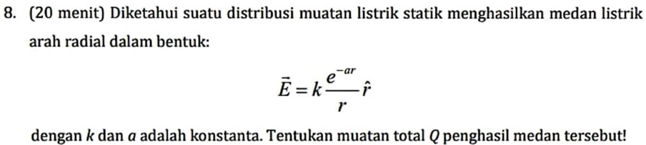
Diketahui:
E(medan listrik)
Dicari Q total = ?
$$persamaan gauss:$$
$$∮\vec{E}⋅d\vec{A}=\frac{q}{ε_{0}}$$
Anggap bentuknya bola:
$$E.A=\frac{q}{ε_{0}}$$
$$\frac{ke^{-ar}}{r}⋅4πr^{2}=\frac{q}{ε_{0}}$$
$$q=ε_{0}⋅\frac{ke^{-ar}}{r}⋅4πr^{2}$$
$$q(r)={4ε}_{0}ke^{-ar}πr$$
Mencari Q total:
$$Q=\lim_{r→∞}{q(r)}$$
$$Q=\lim_{r→∞}{{4ε}_{0}ke^{-ar}πr}$$
$$e^{-a∞}=\frac{e}{∞}=0$$
$$Q=\lim_{r→∞}{{4ε}_{0}k.0.πr=0}$$
$$Q=0$$

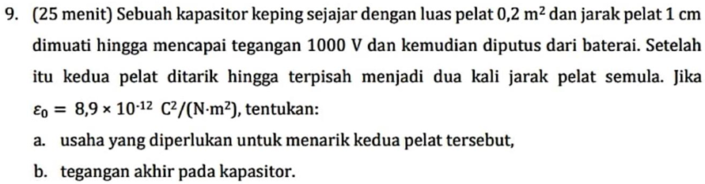
Diketahui:
A=0,2 m2
D1=1cm=0,01m
V1=1000V
Muatan sama (Q1=Q2=Q)
D2=2d1

- Usaha yg diperlukan:
$$W=ΔU$$
$$W=U_{2}-U_{1}$$
$$mencari energi 1 \left(U1\right):$$
$$U_{1}=\frac{1}{2} \frac{Q^{2}}{C_{1}}$$
$$Q=C_{1}V_{1}=C_{2}V_{2}$$
$$kita subtitusikan:$$
$$U_{1}=\frac{1}{2}\frac{C_{1}^{2}V_{1}^{2}}{C_{1}}=\frac{1}{2}C_{1}V_{1}^{2}$$
$$mencari U_{2}:$$
$$U_{2}=\frac{1}{2} \frac{Q^{2}}{C_{2}}=\frac{1}{2}C_{1}^{2}V_{1}^{2}/C_{2}$$

$$mencari C_{2}:$$
$$C_{2}=\frac{ε_{0}A}{d_{2}}$$
$$d2 itu 2 kali d1:$$
$$subtitusikan d_{2}=2d_{1}.$$
$$C_{2}=\frac{ε_{0}A}{{2d}_{1}}=\frac{1}{2}C_{1}$$
$$C_{1}=\frac{ε_{0}A}{d_{1}}$$
$$kita subtitusikan C_{2} ke persamaan U_{2}:$$
$$U_{2}=\frac{1}{2}\frac{2}{1}C_{1}^{2}V_{1}^{2}/C_{1 }$$
$$U_{2}=C_{1}V_{1}^{2}$$
Mencari usaha (W):
$$W=ΔU=U_{2}-U_{1}$$
$$W=C_{1}V_{1}^{2}-\frac{1}{2}C_{1}V_{1}^{2}=\frac{1}{2}C_{1}V_{1}^{2}$$
$$W=\frac{1}{2}\frac{ε_{0}A}{d_{1}}V_{1}^{2}=8,9×{10}^{-5}J.$$
- Mencari tegangan akhir (V2):
$$Q=C_{2}V_{2}$$
$$V_{2}=\frac{Q}{C_{2}}$$
$$kita subtitusikan C_{2}:$$
$$V_{2}=\frac{2Q}{C_{1}}$$
Karna $Q=C_{1}V_{1} juga. jadi kita subtitusikan Q.$
$$V_{2}=2\frac{C_{1}V_{1}}{C_{1}}=2V_{1}=2\left(1000\right)=2000 V.$$

